**MMP 350 CSS Week 4**

## Table of contents

Goals for Week 1

Table of contents 1

Review 1

Week Four: Bootstrap and Node and JQuery 1

## Goals for Week

Introduction to responsive design including media queries

Introduction to JQuery

## Review

## Exercises: Setting Bootstrap, Node js and JQuery

## Node

Mac

<http://blog.teamtreehouse.com/install-node-js-npm-mac>

install xcode

install homebrew

ruby -e "$(curl -fsSL <https://raw.githubusercontent.com/Homebrew/install/master/install>)"

Error: Could not link:

/usr/local/share/doc/homebrew

Please delete these paths and run `brew update`.

Error: Could not link:

/usr/local/share/man/man1/brew.1

brew update

node –v

npm –v

brew upgrade node

brew uninstall node

Windows

**http://blog.teamtreehouse.com/install-node-js-npm-windows**

Install bower

<https://bower.io>

npm –g install bower

Install packages with bower install:

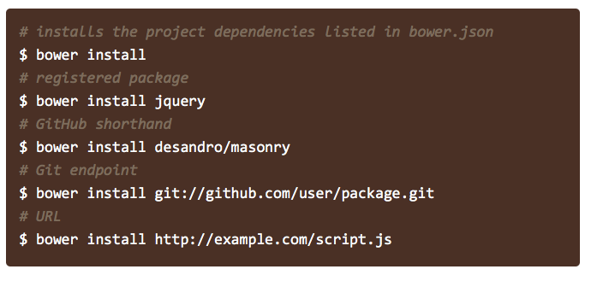

read more about bower install here:

<https://bower.io/docs/api/#install>